Light-Weight Armour for Defence & Security
LWAG 2026
Title of Abstract (or Extended Abstract)
First Authorª, Second Author^{b,c}, Third author^{a,b}

ªFirst affiliation, Adress, City, Postal Code, Country
^{b}Second affiliation, Adress, City, Postal Code, Country
^{c} Third affiliation, Adress, City, Postal Code, Country

Abstract / Extended Abstract
Abstract: Maximum 1 page. Please, include key diagrams, tables, and references.
Extended abstract: Maximum 4 pages. Please include key diagrams, tables and references.
The main text, Font text Arial, Font size: 9, Regular. Line spacing 1,2. Paragraphs are justified (straight- edged) on both left and right. Do not change the page and margin formatting which is A4 and 1 inch in each side.

Figure notation:
Short text notation: font text Arial, regular, font size 8, align centre.
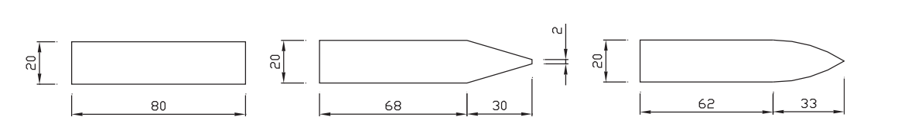
Figure 1: Dimensions of the projectiles given in mm [1].
Long text notation: font text Arial, regular, font size 8, line spacing 1, justified left.
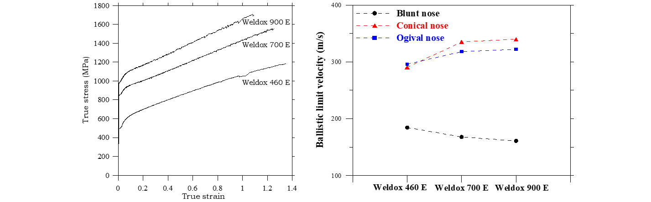
Figure 2: True stress–strain curves under quasi-static condition and room temperature for steels (left) and ballistic limit velocities versus target strength for different nose shapes (right) [2].
Table notation:
Text notation: font text Arial, regular, font size 9,line spacing 1, justified left.

Table 1: Chemical composition (weight %) of Weldox 460 E, Weldox 700 E and Weldox 900 E [1]
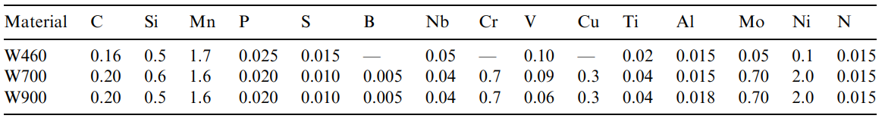
References
Text notation: font text Arial, regular, font size 9, justified left.
- Dey S, Børvik T, Hopperstad OS, Leinum JR, Langseth M. The effect of target strength on the perforation of steel plates using three different projectile nose shapes. International Journal of Impact Engineering 2004;30: 1005-1038.
- Børvik T, Dey S, Morin D, Berstad T, Hopperstad OS. On adiabatic shear banding in high-strength steel. Proceedings of the 17th Light-Weight Armour for Defence and Security Conference (LWAG 2024), June 10-16, 2024, Rocamadour, France.
- …

File naming
Abstract: First author et al_LWAG2026_abstract.doc
Extended abstract: First author et al_LWAG2026_extended abstract.doc

* Corresponding author. Tel.: +99 999999999 E-mail address: xxx@yyy.zz

